Coronavirus: Why are international comparisons difficult?

**By Chris Morris & Anthony Reuben**  
BBC Reality Check



Everyone wants to know how well their country is tackling the coronavirus pandemic, compared with others. But there are all sorts of challenges in comparing countries, such as how widely they test for Covid-19 and whether they count deaths from the virus in the same way.

There is a lot of focus on death rates, but [there are different ways of measuring them](https://www.bbc.com/future/article/20200401-coronavirus-why-death-and-mortality-rates-differ) too. One is the ratio of deaths to confirmed cases - of all the people who test positive for coronavirus, how many go on to die? But different countries are testing in different ways. Early in the outbreak, the UK mainly tested people who were ill enough to be admitted to hospital. That can make the death rate appear much higher than in a country with a wider testing programme. The more testing a country carries out, the more it will find people who have coronavirus with only mild symptoms, or perhaps no symptoms at all.

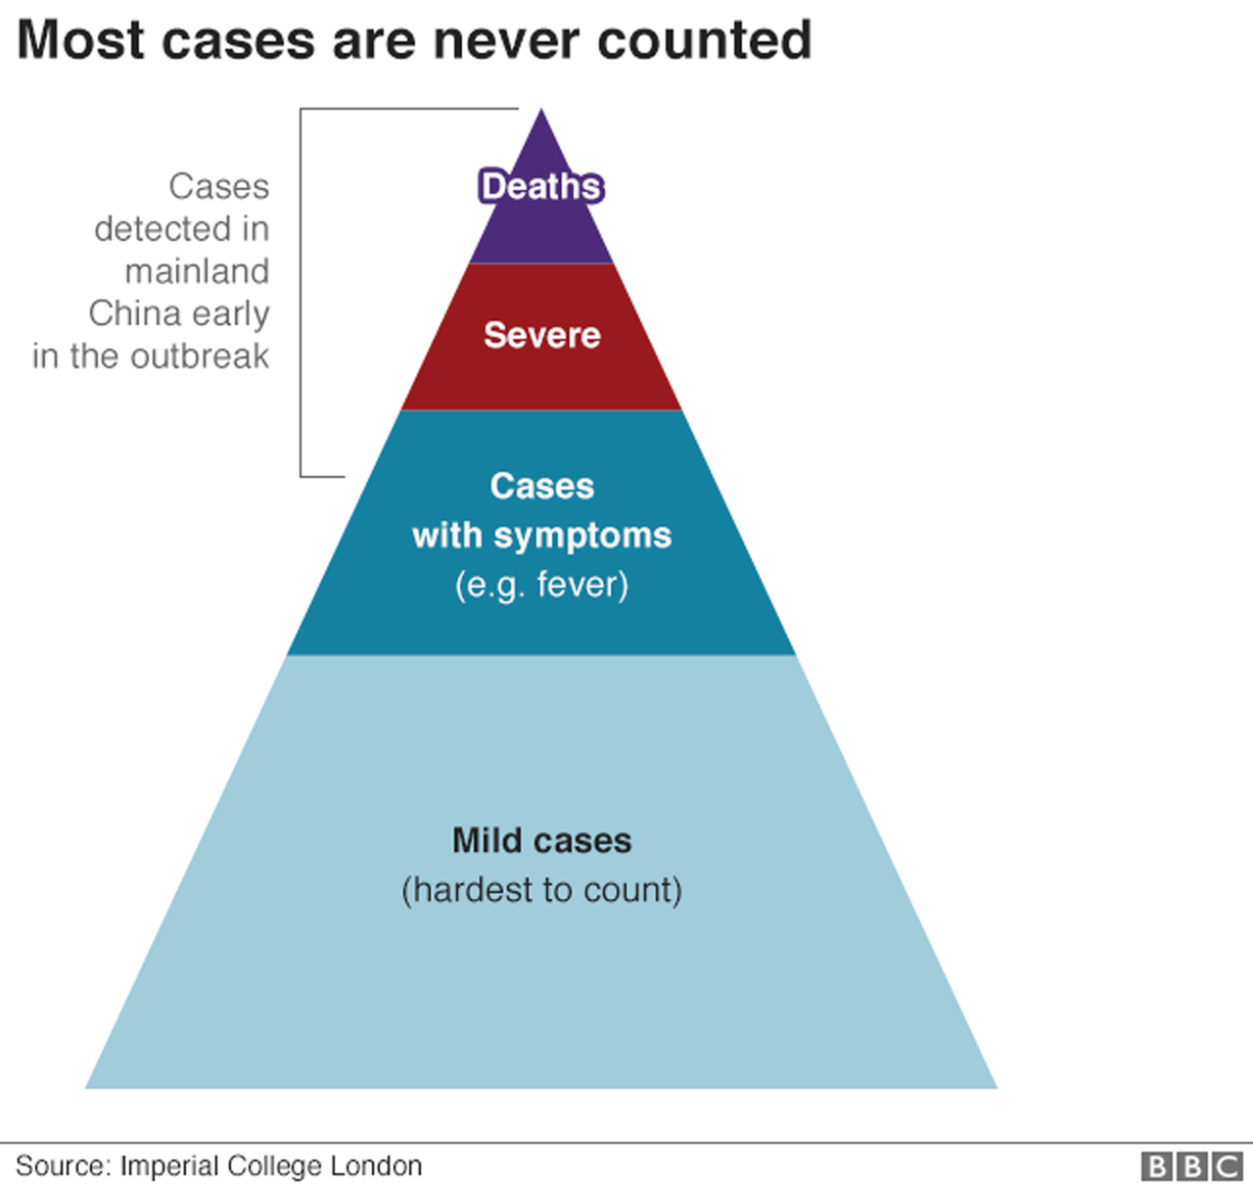

In other words, the death rate in confirmed cases is not the same as the overall death rate. Another measurement is how many deaths have occurred compared with the size of a country's population - the numbers of deaths per million people, for example. But that is determined partly by what stage of the outbreak an individual country has reached. If a country's first case was early in the global outbreak, then it has had longer for its death toll to grow. One way to take account of that is to look at how a country has done since reaching a particular point in the pandemic - the day it recorded its 50th death for example. But even that poses some problems. A country that reaches 50 deaths later should have had more time to prepare for the virus and to reduce the eventual death toll. It is also worth emphasising, when studying these comparisons, that most people who get infected with coronavirus will recover.

There are other factors to take into account beyond the numbers themselves.

It is more difficult to have confidence in data that comes from countries with tightly controlled political systems. Is the number of deaths recorded so far in countries like China or Iran accurate? We don't really know. Calculated as a number of deaths per million of its population, China's figures are extraordinarily low, even after [it revised upwards the death toll in Wuhan by 50%](https://www.bbc.co.uk/news/world-asia-china-52321529). So, can we really trust the data?

There are real differences in the populations in different countries. Demographics are particularly important - that's things like average age, or where people live.

Comparisons have been made between the UK and the Republic of Ireland, but they are problematic. Ireland has a much lower population density, and a much larger percentage of people live in rural areas. It makes more sense to compare Dublin City and County with an urban area in the UK of about the same size (like Merseyside) than to try to compare the two countries as a whole. Similarly, a better though still imperfect comparison for London, Europe's major global city, may be with New York, the biggest global hub in the United States. You also need to make sure you are comparing like with like in terms of age structure. A comparison of death rates between countries in Europe and Africa wouldn't necessarily work, because countries in Africa tend to have much younger populations. We know that older people are much more likely to die of Covid-19.

On the other hand, most European countries have health systems that are better funded than those in most African countries. And that will also have an effect on how badly hit a country is by coronavirus, as will factors such as how easily different cultures adjust to social distancing. Health systems obviously play a crucial role in trying to control a pandemic, but they are not all the same. "Do people actively seek treatment, how easy is it to get to hospitals, do you have to pay to be treated well? All of these things vary from place to place," says Prof Andy Tatem, of the University of Southampton. Another big factor is the level of comorbidity - this means the number of other conditions, such as diabetes, heart disease or high blood pressure - which people may already have when they get infected.